**Project-name: MYNTRA**

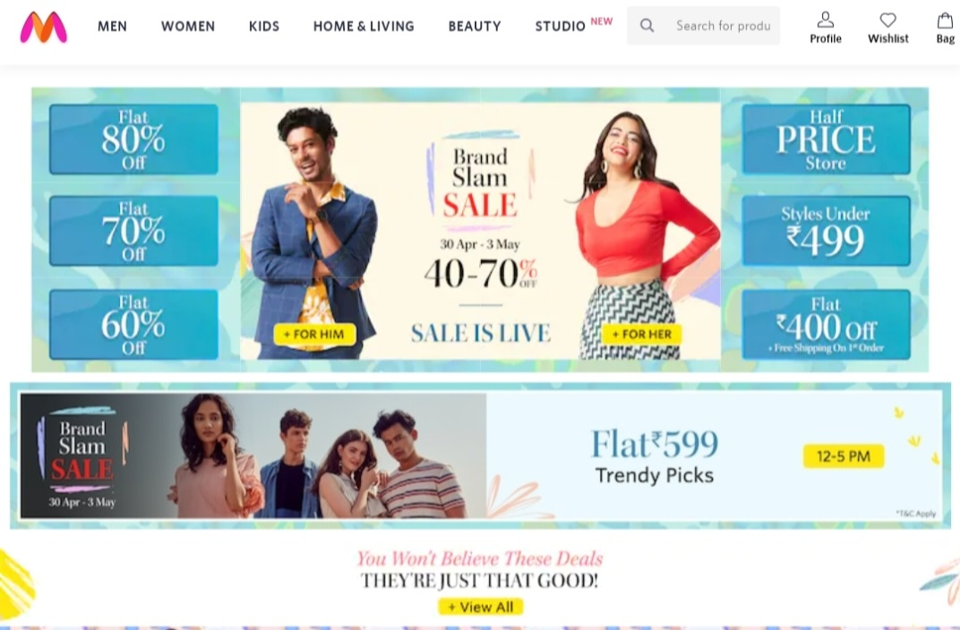

**\*OVERVIEW: Myntra is a one stop shop for all your fashion and lifestyle needs. Being India's largest e-commerce store for fashion and lifestyle products, Myntra aims at providing a hassle free and enjoyable shopping experience to shoppers across the country with the widest range of brands and products on its portal. The brand is making a conscious effort to bring the power of fashion to shoppers with an array of the latest and trendiest products available in the country.**

1. **HOME PAGE:**
   * + - LOGO
       - ICONS - (Men, Women, Kids,,Home &
       - Living,BeautyProfile,Wishlist, Bag)
       - SEARCH BAR
       - SLIDERS WITH ARROWS - (IMAGES)
       - DEALS - (IMAGES)
       - FEATURED - (IMAGES)
       - TRENDING - (IMAGES)

FOOTER – ( CONTACT US , HELPLINES , BRIEF DESCRIPTION

ABOUT THE COMPANY , SOCIAL-MEDIA HANDLE

ICONS , LINK TO MOBILE APP )

1. **REGISTRATION FORM:**

* + - * Login or Sign up
      * E-MAIL ADDRESS
      * Mobile number
      * SHOPPING PREFERENCE

**3. MAIN PAGE:**

* Men: Topwear, Bottom wear,Footwear,Sport & Active Wear,Innerwear & Sleepwear,Fashion Accessories,Indian & Festive Wear,Watches & Sunglasses.
* Women : Indian & Fusion Wear, Western Wear,Sunglasses & Frame, Sports & Active Wear, Footwear,Beauty & Personal care.
* Kids: Boys clothing, Girls Clothing, Footwear,Infants, Kids Accessories,Toys, Personal Care.
* Home & Living: Bed line & Furnishing,Home Decor, Kitchen & Table,Brands,Flooring, Lamp & Light, Storage.
* Beauty: Makeup, Skin care & Body, Haircare , Fragrance, Appliance, Grooming,Beauty Gift & Make up set.
* IMAGES OF THE CHOSEN PRODUCT WITH DETAILS LIKE -

( BRAND , PRODUCT NAME , PRICE , DISCOUNT% )

* ON CLICKING THE IMAGE - (MULTIPLE IMAGES OF THE

PRODUCT WILL APPEAR FROM DIFFERENT ANGLES ,

ZOOM IN , ZOOM OUT

* PRODUCT DESCRIPTION - BRAND , PRODUCT NAME ,
* PRICE , DISCOUNT% (IF ANY) , SIZE CHART ,
* DELIVERY OPTIONS , PRODUCT
* DETAILS , SIZE & FIT , MATERIAL & CARE ,
* SPECIFICATIONS , RATINGS , CUSTOMER REVIEWS
* WITH IMAGES (IF ANY )
* LOWER HALF OF THE PAGE - RELATED PRODUCTS

1. **PAYMENT PAGE:**

ADDRESS SELECTION

PAYMENT METHOD - (PHONEPE , GOOGLE PAY , BHIM UPI ,

COD , CREDIT/DEBIT CARD , NET

- BANKING , EMI , PAYTM)